**Decision Trees**

A decision tree is a tree where each node represents a feature(attribute), each link(branch) represents a decision(rule) and each leaf represents an outcome(categorical or continues value).

***Why Decision trees?***

We have couple of other algorithms there, so why do we have to choose Decision trees?

1. Decision tress often mimic the human level thinking so its so simple to understand the data and make some good interpretations.
2. Decision trees actually make you see the logic for the data to interpret(not like black box algorithms like SVM,NN,etc..)

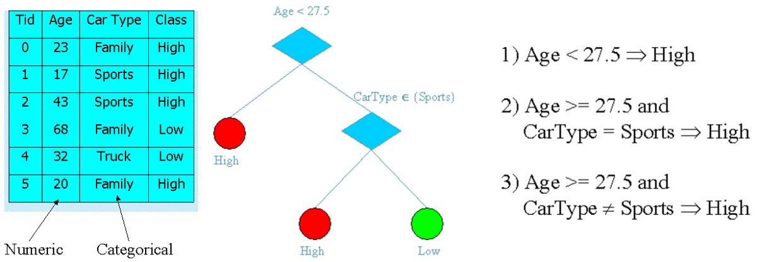

**Okay so how to build this??**

There are couple of algorithms there to build a decision tree ,we only talk about a few which are

1. CART (Classification and Regression Trees) → uses ***Gini Index(Classification)*** as metric.
2. ID3 (Iterative Dichotomiser 3) → uses ***Entropy function***and [***Information gain***](https://en.wikipedia.org/wiki/Information_gain_in_decision_trees)as metrics.